Normalization Layers - a quick study
Every experiment is on cifar 10 with fully connected layers - looking at the probability of activation.

SeLU 10 layers :
10 hidden layers 256 hidden units.

Epoch 0 : 10 % accuracy
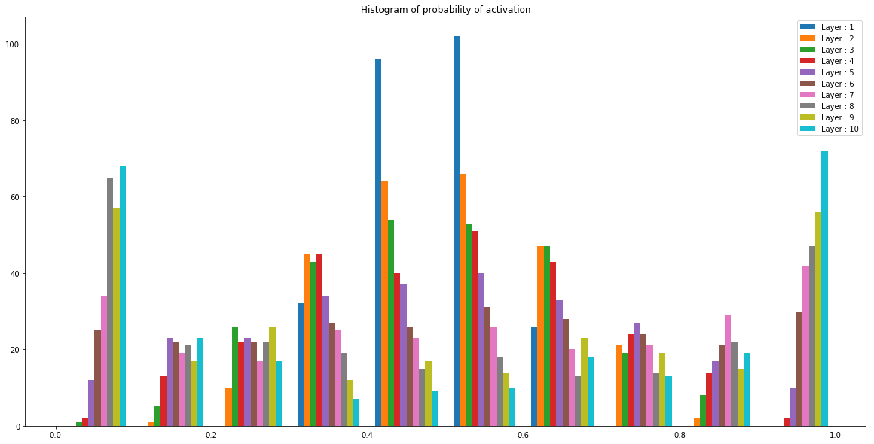

Epoch 20 : 50 % accuracy
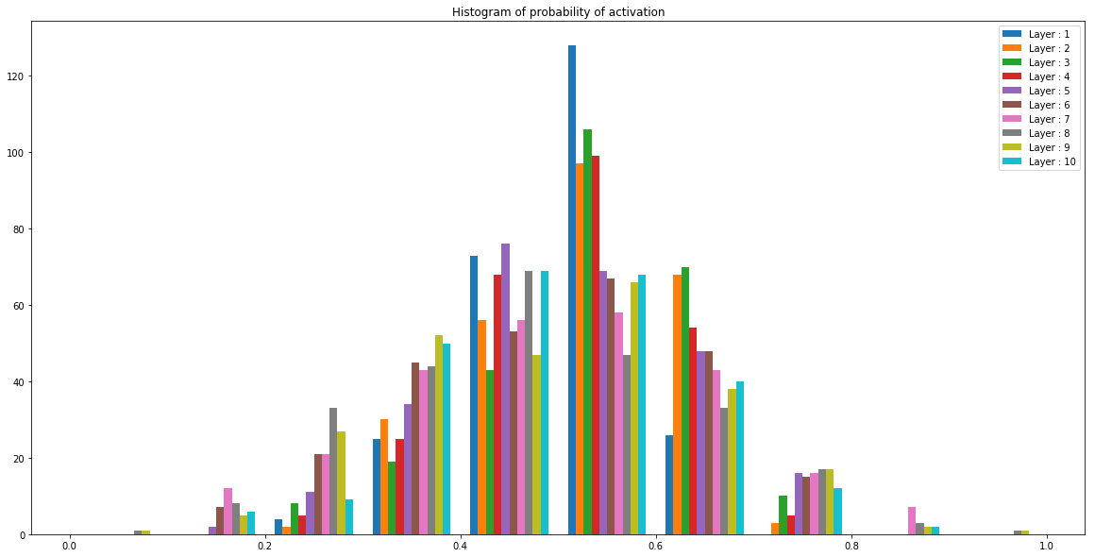

Selu 4 layers :

Epoch 0 :
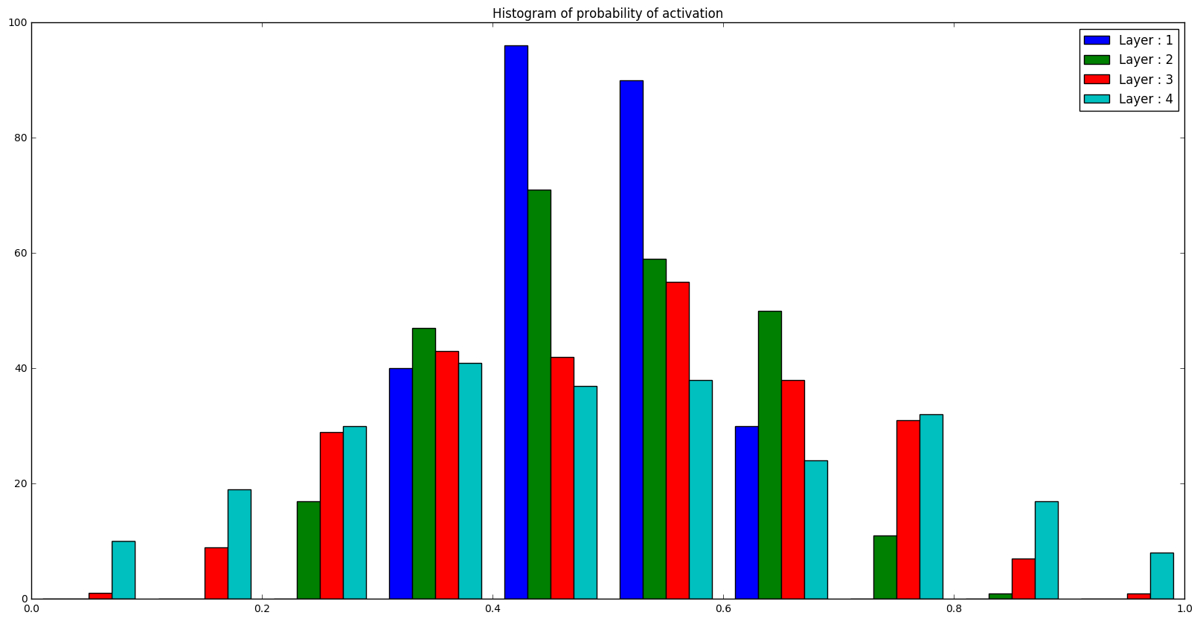

Epoch 40 : 48 % accuracy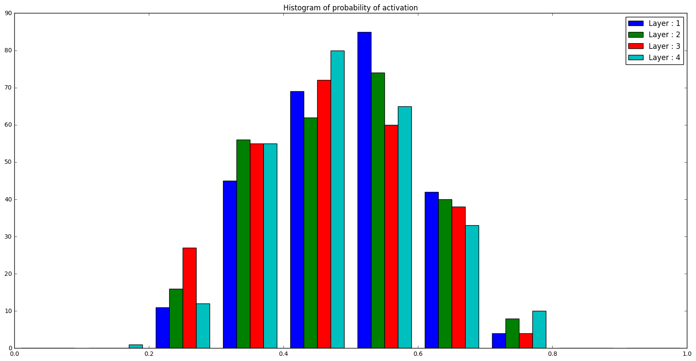

Batch Normalization :
10 hidden layers 256 hidden units.

Epoch 0 : 10 % accuracy
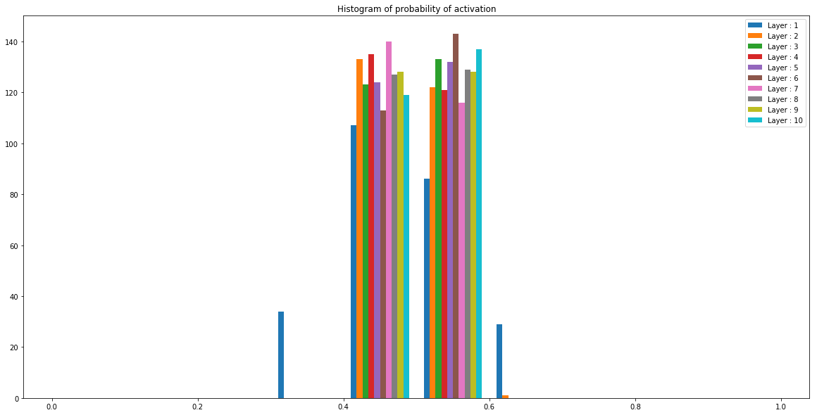

Epoch 13 : 52 % accuracy
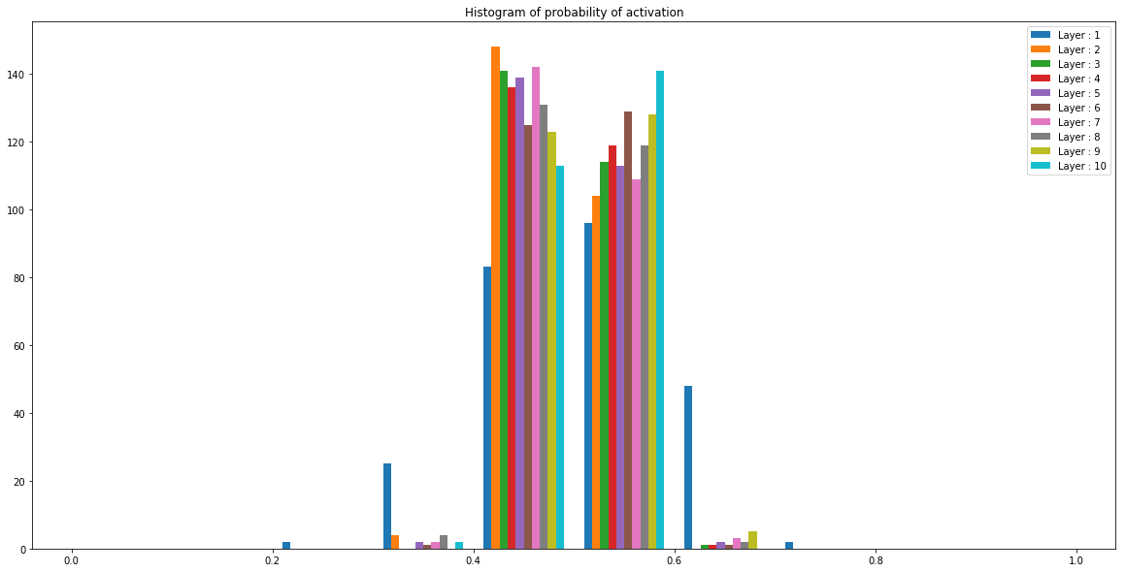

Layer Normalization :

Epoch 0 : 10 % accuracy
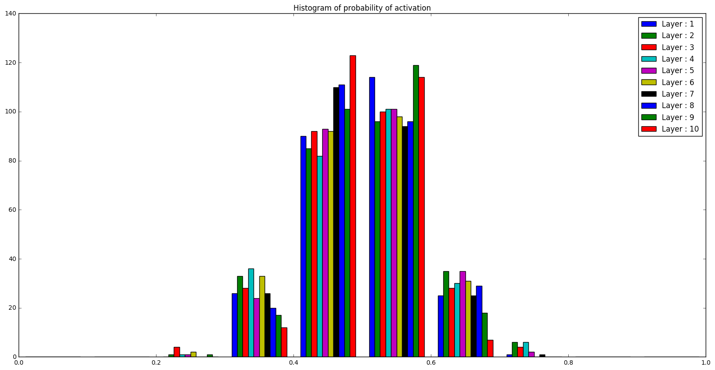

Epoch 20 : 41 % accuracy training loss of 0.5 -> Overfitting !

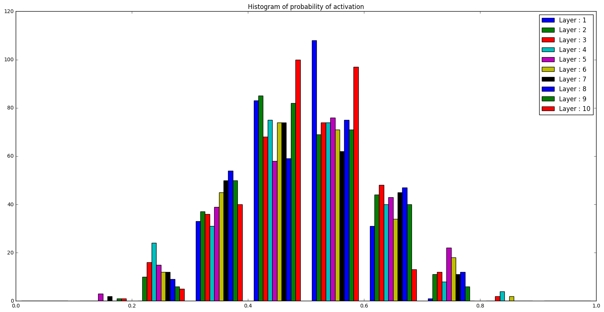

Weight Normalization 10 layers :

Epoch 0 : 10 % accuracy
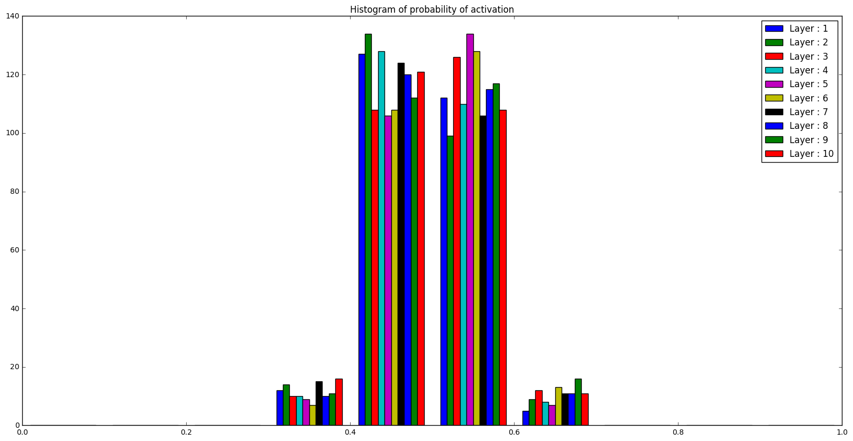

Epoch 20 : 53 % accuracy training loss 0.5

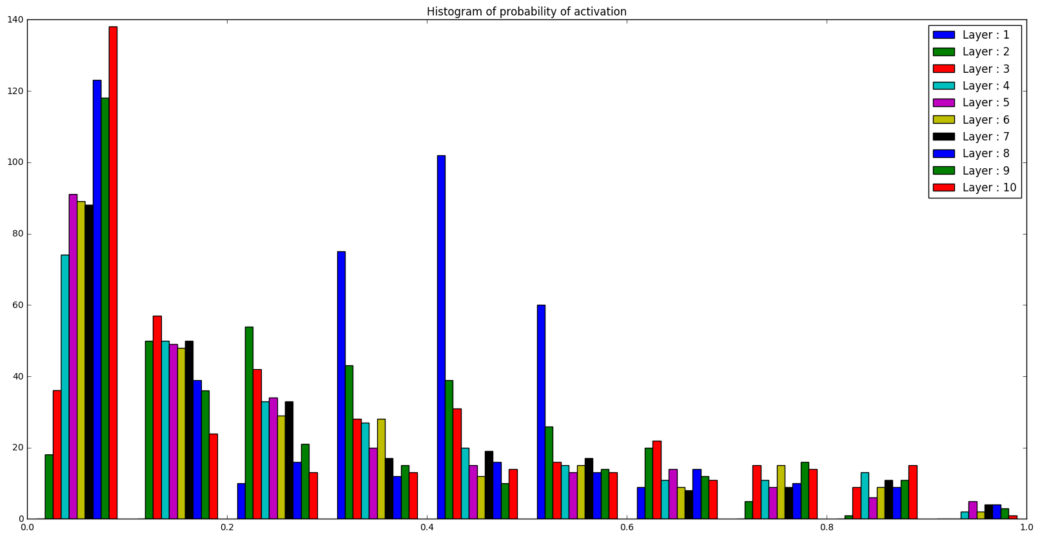

Commentary :
- The training error never goes to 0 - Selu we have 1.3 training error, same for batch norm…

